Home Assignment
1) Get the List of Open weight LLM from different service providers
a) Open ai
gpt-oss-120b: A 117-billion parameter Mixture-of-Experts (MoE) model with 5.1 billion active parameters per token, optimized for high-end single-GPU (H100) agentic and reasoning tasks.
gpt-oss-20b: A medium-sized, highly efficient conversational and tool-use model designed for consumer hardware and low-latency environments

b) Qwen
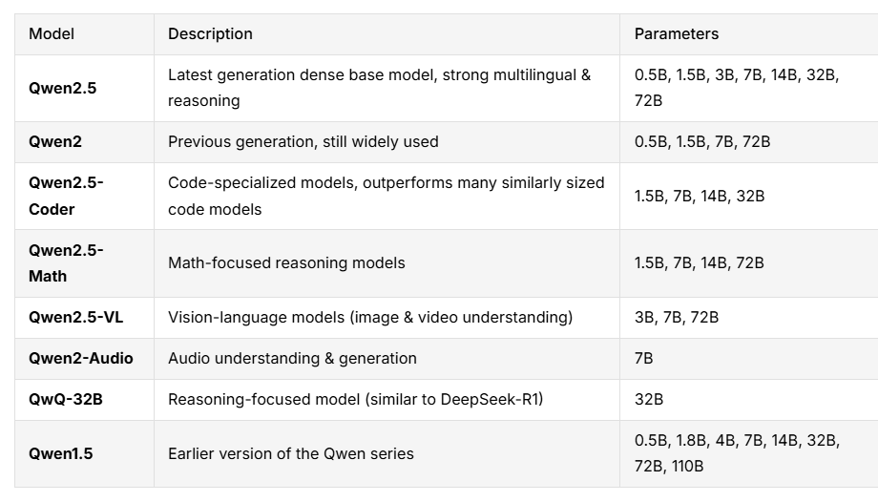
c) Deepseek
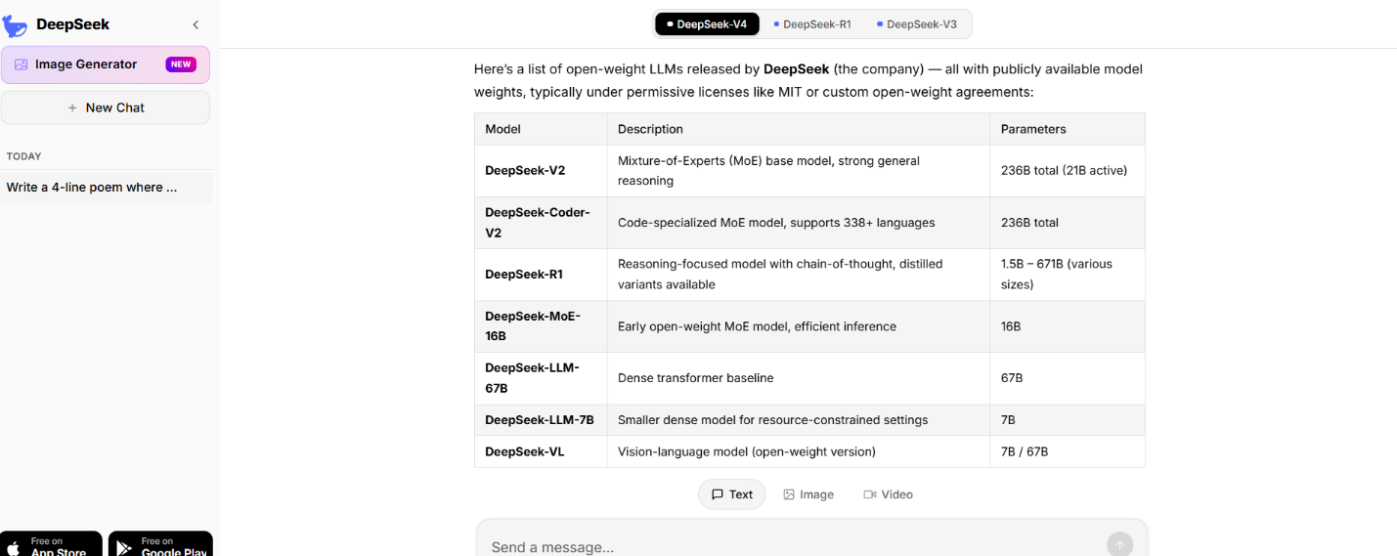
2)Hallucination check for the below prompt
Write a 4-line poem where every line ends with a word that
strictly rhymes with the word ‘Silver’.
a)qwen ai
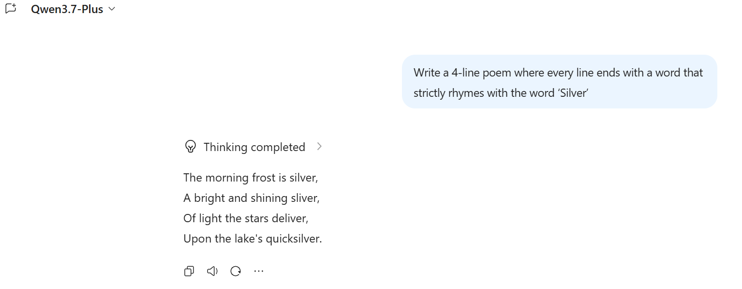
b) Chatgpt
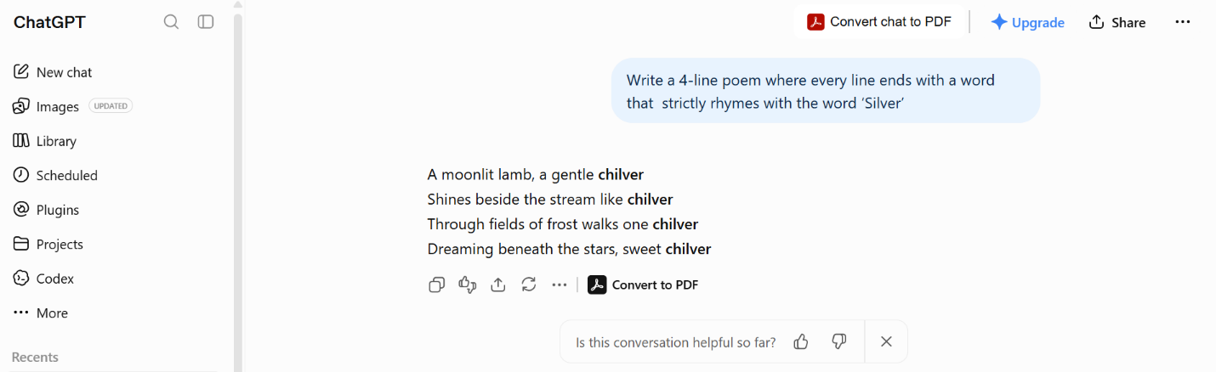
c)Deepseek
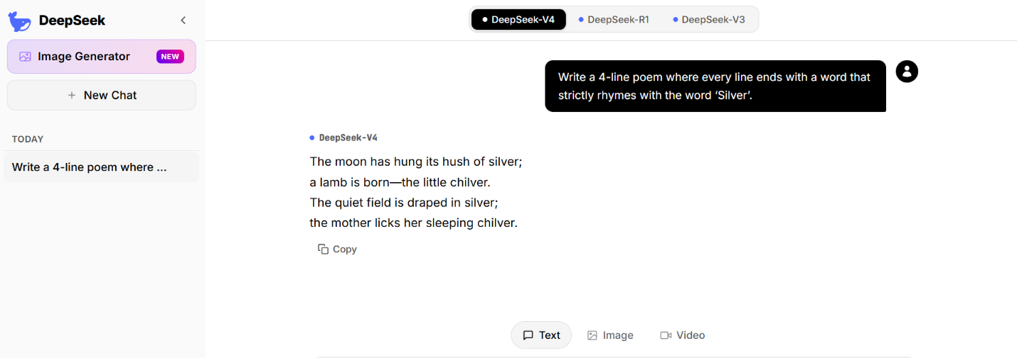
d)Gemini
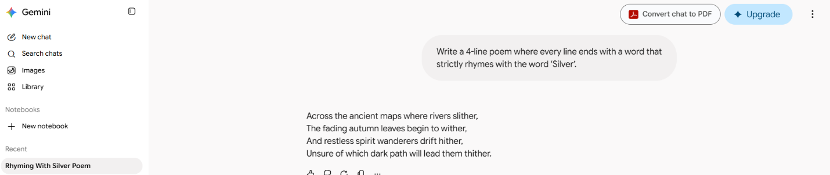
3) From open router take the model details with Context window for any 10 models from 3 service providers

Models=Context
DeepSeek V4.1 Flash= 1.0M
DeepSeek: DeepSeek V4 Flash Vision Exp= 1.0M
OpenAI: GPT Image 2.5 Sunburst=400K
OpenAI: GPT Image 2.5 Flare=400K
OpenAI: GPT-6 Astra (batch)= 1.1M
OpenAI: GPT-6 Astra=1.1M
Google: Gemini 3.8 Flash=1.0M
Google: Gemini 3.8 Flash (batch)=1.0M
Anthropic: Claude Fable 5.1 (batch)= 1.0M
Anthropic: Claude Fable 5.1= 1.0M

